The Hazee
Annual Art Award for Young Artists
Exhibition – April 29, 2022 – May 8th, 2022
Art and Application Drop Off on or before April 23, 2022– See Application Rules
Hazee Awards to be held on May 3, 2022
Guidelines
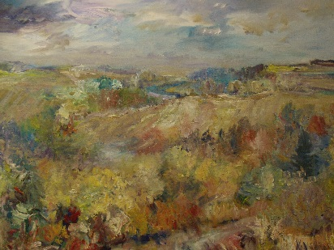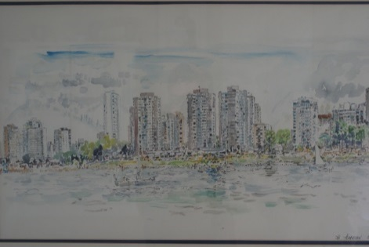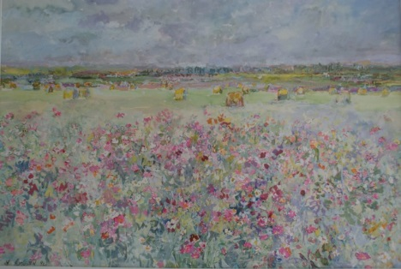
Hazel Asmussen was a nurse by profession but she painted throughout her life. Her pieces are in private and public collections including the City of North Battleford. Hazel loved her art and continued to paint until she lost her eyesight. Her paintings have a spontaneous and dynamic style and she infused each piece with energy, light and colour. Her focus was on florals and landscapes and the pieces not only captured a sense of place, but also showed her own lively personality.
Rob and Nora Rongve enjoyed Hazel’s friendship for many years and own several of her paintings. They have established this competition as a way to honour her memory by encouraging youth who have an interest in visual arts.
Contest and Exhibition Theme:

“A positive life in a year of change: Playfulness, resilience, compassion, personal and community well-being.”
(See Official Rules & Guidelines for complete details.)

Awards: The Hazee Artist of the Year Award of $500
The Hazee Artistic Achievement Award of $300
The Hazee Award of Creative Excellence – two awards of of $100
Children and youth between age 7 - 20, who reside within a 100 km radius of North Battleford are invited to submit the completed application form along with one art piece to The Chapel Gallery.
- Applications and artwork will be accepted at The Chapel Gallery - Wednesday to Sunday during the hours of Noon to 4:00pm. Or call 306-445-1760 to arrange a time.
- The deadline for submission and art drop off is Saturday April 23.
The Hazee – 2022 Application
Theme: “A positive life in a year of change: Playfulness, resilience, compassion, personal and community well-being.”
- Contact Information

Name:____________________________ Phone:________________________
Mailing address:____________________________________________________
Email:____________________________ School:_______________________

- Art Information
Artist Name: ______________________________________Grade: __________
Title: _____________________________________________________________
Dimensions:_____________________________________________________________
Materials/Media :________________________________________________________
Theme
Please write a paragraph in the space below describing how your artwork relates to the theme: “A positive life in a year of change: Playfulness, resilience, compassion, personal and community well-being.” (100-200 words)

Official Rules and Guidelines
- All submissions must have a completed application form.

- The artwork submitted must be an original piece created by the submitting artist. No copyrighted material is allowed. Only one piece per artist is allowed. Submissions will be accepted in all media, in 2 dimension and 3 dimension form.

- Artwork must be ready to display with hardware or hanging method included.

- The artist must between the Ages of 7 -20 and live within a 100 km of North Battleford.

- All artwork will be judged by The Hazee committee. Decisions of the committee are final. Winners will be notified using the contact information provided on the application.

- Artwork will be judged on the following criteria:

- Creativity and originality
- Quality of artistic composition and overall design based on the theme;
- Skillfull use of media and materials;
- Overall impression of the art – does it stand on its own as a complete and outstanding work of art?

- 2022 awards are: Artist of the Year; $500; Artisitic Achievement Award $300; two Awards of Creative Excellence of $100. Winners must accept the prizes as awarded.

- All submissions will be part of the public exhibition that will take place at The Chapel Gallery from April 29 – May 8, 2022

- The Hazee Awards will take place on Tuesday May 3 between 7:00pm – 8:00 pm with the awards at 7:30pm.

- Artwork can be picked up at the Chapel Gallery between between May 8 – May 15th between Noon – 4pm. Please contact us at 306-445-1760 to arrange another time if this is not convenient.

Please read and sign:
____ I have reviewed and understand the Official Rules and Guidelines as presented above. The artwork I am submitting is my own creation and I agree to it being on exhbition at the Chapel Gallery

_____ I agree to photographs of my art work being used for publicity purposes by the Chapel Gallery.

_____ If I am an award winner I agree to grant permission for the image of my person/my child to be used in promotion of The Hazee and The Chapel Gallery.

Signature:__________________________ Date: ____________________
Artist

Signature:__________________________ Date: ____________________
Signature of Parent/Guardian

